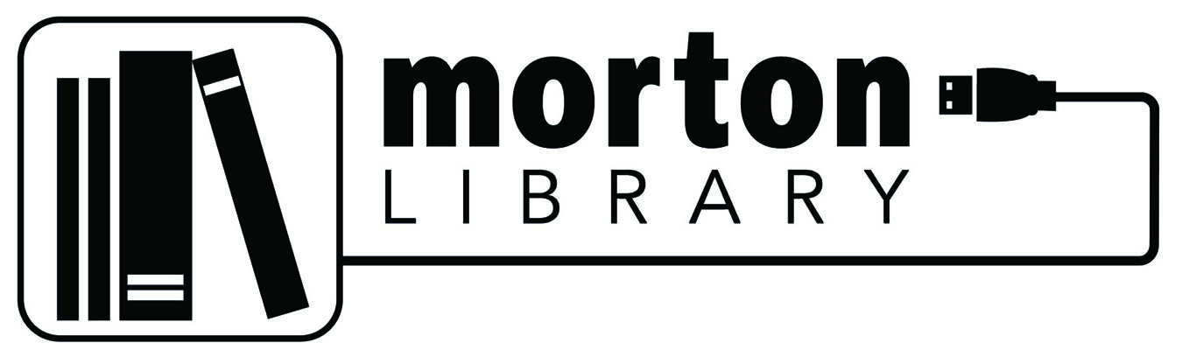

MEETING NOTICE & AGENDA –
DECCENNIAL COMMITTEE MEETING

JUNE 14, 2023
5:45 PM, OR IMMEDIATELY FOLLOWING THE REGULAR BOARD MEETING
MORTON LIBRARY BOARD ROOM

- Roll Call

- Public Comment

- New Business
  - Review process
  - Review documents supplied to the committee

- Adjournment

Next Meeting: August 16, 2023 – immediately after the regular library board meeting

The mission of the Morton Public Library is to actively connect people to books, resources, and technology; and provide opportunities for learning, collaboration and enjoyment.

